Waterfall –

First figure out the requirements of the software

Second figure out what you want the software to do, this can be something as simple as doing math equations

Third begin development for the software, start with the most basic functions first and work from there

Fourth test your software and fix any bugs you might encounter

Fifth roll out the software as a package or download and continue to maintain any issues that arise

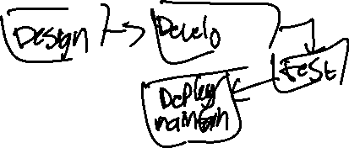

Incremental development –

First figure out the requirements of the software

Second figure out what you need the software to do

Third begin development for the software, creating functions as you go (this can start as basic set/get and evolve to create an entire playlist in spotify)

Fourth test each function before moving on to the next to make sure you won’t encounter any major bugs (repeat steps 3-4 until your software is complete)

Fifth do the final testing of the software

Sixth roll out the software as a package or download and continue to maintain any issues that arise

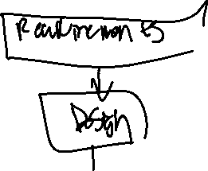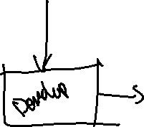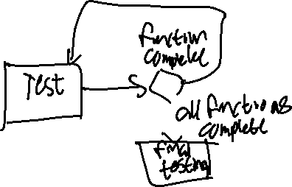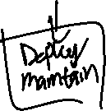

Integrate and configure –

First figure out the requirements of the software

Second figure out what you want the software to do

Third find an open source code that can be built off of allowing you to reuse assets for quicker development

Fourth test your software and fix any bugs that are present

Fifth roll out your software as a package or download and continue to maintain any bugs that arise

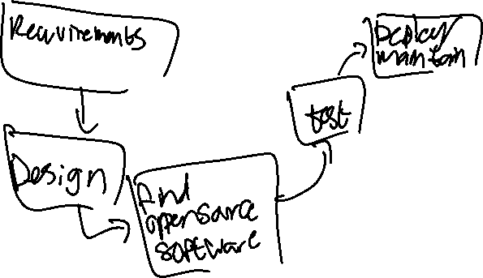

Sorry for the lack of specificity, I did not have internet access while making this

